HTML Notes

Notes taken whilst doing tutorials in FreeCodeCamp

You don’t need to wait until your pages are finalized; inserting a table of contents can be an early step in creating your document. As the pages of your document develop, Word helps you keep the table of contents up to date.

This doc isn’t just for reading, it’s for trying too. Watch for the Try it text in red throughout this document so you can learn by doing.

# Insert a table of contents

To add a TOC (short for table of contents), just decide where you want it. Word will do the heavy lifting.

Try It: Hit Enter after the first paragraph in this doc to get a new line. Then, go to the **References** tab, select **Table of Contents**, and choose a TOC from the gallery.

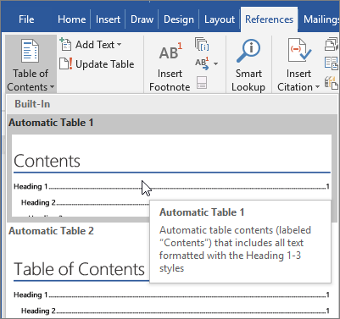

Voila! Word found all the headings in this document and added a TOC.

# Update when things change

The heavy lifting doesn’t stop with creating a TOC. Word is smart enough to keep track of where things are, so you don’t have to. When things change, just update the TOC.

Try It: Update your TOC.

1. Place your cursor after the paragraph that ends with, “When things change, just update the TOC” (above), and then hit Ctrl+Enter to push this section onto page 3.
2. Go to your TOC and click anywhere in it. Then click **Update Table**, and click **OK** (**Update page numbers only** is selected by default).

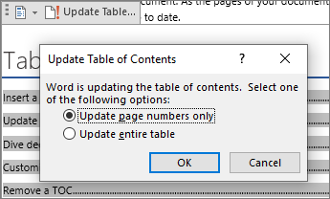

Word updated the entry for Update when things change from page 2 to page 3.

Use styles for headings

The TOC magic is in the styles that are used to format headings. The heading for this section, Use styles for headings, might look like a heading, but it doesn’t act like one. It’s formatted in pieces (font size, underline) instead of being formatted with a style. See how it’s not in the TOC you added? To add a heading to a TOC, it needs to be formatted with the Heading 1 style.

Try It: Update the style, and then update the TOC.

1. Click in the heading above (Use styles for headings)—be sure to just click, don’t select anything.
2. On the **Home** tab, find **Styles**, and click **Heading 1** (keyboard shortcut: Alt+Ctrl+1).
3. Update your TOC like you did before, but this time, select **Update entire table** (instead of **Update page numbers only**) since more than the page numbers changed.

Now Word knows that paragraph is a heading, and includes it in the TOC.

# Dive deeper than Heading 1

Want more levels in your TOC? That’s where the rest of the Heading styles come in. Mark subheadings in your document with Heading 2, lower-level headings with Heading 3, and so on.

Try It: Apply **Heading 2** to the paragraph below (Add a Level 2 TOC entry), and then update your TOC like you did before. Remember to update the entire table!

Add a Level 2 TOC entry

**Under the hood**: Heading styles hold formatting, font, size, color, and more. They also hold a paragraph format known as an outline level, which is picked up by the TOC.

# Customize your TOC

The space between an entry and its page number in a TOC is known as a tab leader. By default, Word makes the tab leader a row of dots (dot leader), but you can easily switch to something else, like an underline. You don’t need to start over—you don’t even need to select the TOC. Word knows where it is. Just use the Custom TOC option to make this type of change, and Word will do its thing.

Try It: Change the dot leader to an underline.

1. On the **References** tab, click **Table of Contents**, and then near the bottom, click **Custom Table of Contents**.
2. From the list of **Tab Leader** options, select **Line** (last choice in the list), and click **OK**.

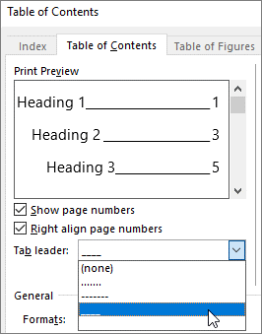

1. When you’re prompted to replace the TOC, click **Yes**.

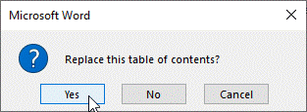

And just like that, Word found your TOC and changed the tab leader from dots to an underline.

# Remove a TOC

You can’t delete a TOC like you can a picture or other things in a doc. Well, you can, but if you do it too many times, your TOC can get out of whack. Remember the heavy lifting Word does for you? All the scaffolding needs to be removed too. Tell Word to remove the TOC, and Word will clean up after itself.

Try It: On the **References** tab, click **Table of Contents**, and then near the bottom, click **Remove Table of Contents**.

Poof! The TOC, and the stuff to make it work, are gone from the document. But you can add your TOC back any time, in any location. Word will remember everything you did—even your change to the tab leader.

**Under the hood:** The stuff Word removes is a collection of hidden bookmarks that keep track of the heading text and page number shown in the TOC.

# Explore more

If you want to customize your TOC even more, give these a try. (If you didn’t add your TOC back, do that now. You can add it above this section if you’d like. Or, if removing it is the last thing you did, press Ctrl+Z to undo.)

## Change text formatting of the TOC entries

Try it: In your TOC, select an entire Level 1 entry and make a formatting change. For example, change the font color to blue. (Make sure you select only one TOC entry, including the tab leader and page number. Notice that even though the whole TOC may look like it’s selected, the one entry you select will have darker highlighting.)

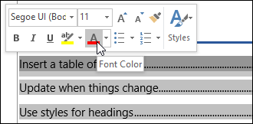

Like the rest of the TOC magic, all the TOC Level 1 entries changed too.

**Under the hood:** Okay, it’s not really magic. The TOC entries are assigned to a style (TOC 1, TOC 2, and so on), and those styles are set to update automatically whenever you make a formatting change.

## Change the number of TOC levels

Try it: Include only Heading 1 headings in your TOC, no subheadings.

1. On the **References** tab, click **Table of Contents**, and then near the bottom, click **Custom Table of Contents**.
2. Change **Show levels** to **1** and click **OK**.

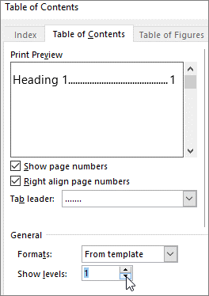

1. When you’re prompted to replace the TOC, click **Yes**.
2. Verify your TOC no longer includes subheadings, such as Add a Level 2 TOC entry.

# Get help in Word

The **Tell me** search box takes you straight to commands and Help in Word.

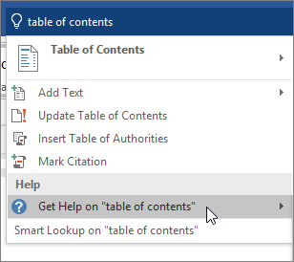

Try it: Go to **Tell me what you want to do** near the top of the window, and then type what you want to do.

For example, type:

* **table of contents** to quickly get to the Table of Contents options and other TOC help topics
* **styles** if you want to know more about using styles in Word
* **help** to go to Word help
* **training** to see the list of Word training courses

# Let us know what you think

Please [give us feedback on this learning guide](https://go.microsoft.com/fwlink/?linkid=2027721), so we can provide content that’s truly useful and helpful. Thanks!

HTML5 elements introduces more descriptive HTML tags. These tags include header, footer, nav, video, article, section and others.

These tags make your HTML easier to read, and also help with Search Engine Optimization (SEO) and accessibility.

The mainHTML5 tag helps search engines and other developers find the main content of your page.

<h2>CatPhotoApp</h2>

<main>

<p>Kitty ipsum dolor sit amet, shed everywhere shed everywhere stretching attack your ankles chase the red dot, hairball run catnip eat the grass sniff.</p>

<p> Purr jump eat the grass rip the couch scratched sunbathe, shed everywhere rip the couch sleep in the sink fluffy fur catnip scratched.</p>

</main>

You can add images to your website by using the img element, and point to a specific image's URL using the src attribute.

An example of this would be:

<img src="https://www.your-image-source.com/your-image.jpg">

Note that imgelements are self-closing.

All imgelements **must** have an altattribute. The text inside an altattribute is used for screen readers to improve accessibility and is displayed if the image fails to load.

You can use anchorelements to link to content outside of your web page.

anchorelements need a destination web address called an hrefattribute. They also need anchor text. Here's an example:

<a href="https://freecodecamp.org">this links to freecodecamp.org</a>

1. Elements

|  |  |  |  |
| --- | --- | --- | --- |
| Element | opening tag and a closing tag |  |  |
| H Element (Header) | <h1>Hello</h1>? |  |  |
| H2 Sub-header | <h2>Hello</h2>? |  |  |
| P elements (Paragraph)  **Query**  P2 (More add on paragraphs)  <p2>More info</p2> | <p>I'm a p tag!</p> | <h2>CatPhotoApp</h2>  <main>  <p>Kitty ipsum dolor sit amet, shed everywhere shed everywhere stretching attack your ankles chase the red dot, hairball run catnip eat the grass sniff.</p>  <p>Purr jump eat the grass rip the couch scratched sunbathe, shed everywhere rip the couch sleep in the sink fluffy fur catnip scratched.</p>  </main> |  |
| Image Element | <img src="https://www.your-image-source.com/your-image.jpg">  Alt:  <img src="https://www.your-image-source.com/your-image.jpg" alt="Author standing on a beach with two thumbs up."> | Note that img elements are self-closing. | All imgelements **must** have an altattribute. The text inside an altattribute is used for screen readers to improve accessibility and is displayed if the image fails to load. |
| Anchor Elements – link Externally  Then your browser will display the text **"this links to freecodecamp.org"** as a link you can click. And that link will take you to the web address **https://www.freecodecamp.org** | <a href="https://freecodecamp.org">this links to freecodecamp.org</a> |  |  |
| Link to Internal Sections of a Page with Anchor Elements To create an internal link, you assign a link's hrefattribute to a hash symbol #plus the value of the idattribute for the element that you want to internally link to | <a href="#contacts-header">Contacts</a>  <h2 id="contacts-header">Contacts</h2> |  |  |
| Nest an Anchor Element within a Paragraph | <p> View more  <a href="http://freecatphotoapp.com" target="_blank">cat photos</a>  </p> |  |  |
| Make Dead Links Using the Hash Symbol |  | Sometimes you want to add aelements to your website before you know where they will link.  This is also handy when you're changing the behavior of a link using JavaScript, which we'll learn about later. |  |
| Turn an Image into a Link | <a href="#"><img src="https://bit.ly/fcc-running-cats" alt="Three kittens running towards the camera."></a> |  |  |
| Commenting vs. Uncomment | <!--, and ends with a --> |  |  |

HTML5 elements introduces more descriptive HTML tags. These tags include header, footer, nav, video, article, section and others.

|  |  |  |  |  |
| --- | --- | --- | --- | --- |
| main |  |  |  |  |
| header |  |  |  |  |
| footer |  |  |  |  |
| nav |  |  |  |  |
| article |  |  |  |  |
| section |  |  |  |  |
|  |  |  | <https://images.unsplash.com/photo-1518791841217-8f162f1e1131?ixlib=rb-1.2.1&ixid=eyJhcHBfaWQiOjEyMDd9&w=1000&q=80> |  |

Create a web form

<form action="/submit-cat-photo">

<input type="text" placeholder="cat photo URL"><button type="submit">Submit</button>

</form>

|  |  |  |  |
| --- | --- | --- | --- |
| Create a Text Field | <input type="text"> | Note that inputelements are self-closing. |  |
| Add Placeholder Text to a Text Field | <input type="text"placeholder="cat photo URL"> | Placeholder text is what is displayed in your inputelement before your user has inputted anything. |  |
| Create a Create a Form Element | <form action="/submit-cat-photo">  <input type="text" placeholder="cat photo URL"></form> | You can build web forms that actually submit data to a server using nothing more than pure HTML. You can do this by specifying an action on your formelement. |  |
| Add a Submit Button to a Form | <button type="submit">this button submits the form</button>  <form action="/submit-cat-photo">  <input type="text" placeholder="cat photo URL">  </form><button type="Submit">Submit</button> | Let's add a submitbutton to your form. Clicking this button will send the data from your form to the URL you specified with your form's actionattribute. |  |
| Use HTML5 to Require a Field |  | For example, if you wanted to make a text input field required, you can just add the attribute requiredwithin your inputelement, like this: <input type="text" required> |  |
| Create a Set of Radio Buttons Example 1 | <form action="/submit-cat-photo">  <label>  <input type="radio" name="indoor-outdoor">Indoor  </label>  <label>  <input type="radio" name="indoor-outdoor">Outdoor  </label>  <input type="text" placeholder="cat photo URL" required>  <button type="submit">Submit</button>  </form> | You can use radio buttonsfor questions where you want the user to only give you one answer out of multiple options.  Radio buttons are a type of input. |  |
| Create a Set of Radio Buttons Example 2 | <form action="/submit-cat-photo">  <label for="indoor"><input id="indoor" type="radio" name="indoor-outdoor"> Indoor</label>  <label for="outdoor"><input id="outdoor" type="radio" name="indoor-outdoor"> Outdoor</label><br>  <input type="text" placeholder="cat photo URL" required>  <button type="submit">Submit</button>  </form> |  |  |
| Create Checkboxes  Example 1 | <label><input type="checkbox" name="personality"> Indoor</label>  <label><input type="checkbox" name="personality"> Outdoor</label>  <label><input type="checkbox" name="personality">  Mountains</label>  <input type="text" placeholder="cat photo URL" required>  <button type="submit">Submit</button>  </form> |  |  |  |
| Example 2 | <label for="indoor"><input id="indoor" type="checkbox" name="personality"> Indoor</label>  <label for="indoor"><input id="indoor" type="checkbox" name="personality"> Indoor</label>  <label for="outdoor"><input id="outdoor" type="checkbox" name="personality"> Outdoor</label><br>  <input type="text" placeholder="cat photo URL" required>  <button type="submit">Submit</button>  </form> |  |  |
|  |  |  |  |
|  |  |  |  |
|  |  |  |  |
|  |  |  |  |

H Elements

Do you see the code in your code editor that says <h1>Hello</h1>? That's an HTML element.

This element tells the browser about the structure of your website. h1elements are often used for main headings, while h2elements are generally used for subheadings. There are also h3, h4, h5and h6elements to indicate different levels of subheadings.

P Elements:

P elements are the preferred element for paragraph text on websites. pis short for "paragraph".

1. Sdsdcd
2. WWDASD
3. Commenting vs. Uncomment HTML

Commenting is a way that you can leave comments for other developers within your code without affecting the resulting output that is displayed to the end user.

Commenting is also a convenient way to make code inactive without having to delete it entirely.

Comments in HTML starts with <!--, and ends with a -->

## **Create a Bulleted Unordered List**

HTML has a special element for creating unordered lists, or bullet point style lists.

Unordered lists start with an opening <ul>element, followed by any number of <li>elements. Finally, unordered lists close with a </ul>

For example:

<ul>  
  <li>milk</li>  
  <li>cheese</li>  
</ul>

<ul>

* Food
* Humans
* Cuddling

<li>Food</li>

<li>Humans</li>

<li>Cuddling</li>

</ul>

## **Create an Ordered List**

<ol>

1. Dogs
2. Flea Treatment
3. Garfield

<li>Dogs</li>

<li>Flea Treatment</li>

<li>Garfiled</li>

</ol>

---------------------------

<p>Things cats love:</p>

<ul>

<li>cat nip</li>

<li>laser pointers</li>

<li>lasagna</li>

</ul>

<p>Top 3 things cats hate:</p>

<ol>

<li>Dogs</li>

<li>Flea Treatment</li>

<li>Garfiled</li>

</ol>

## **Create a Text Field**

Input elements are a convenient way to get input from your user.

You can create a text input like this:

<input type="text">

Note that inputelements are self-closing.

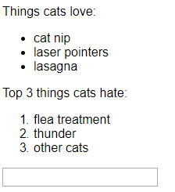

## **Add Placeholder Text to a Text Field**

Placeholder text is what is displayed in your inputelement before your user has inputted anything.

You can create placeholder text like so:

<input type="text" placeholder="this is placeholder text">

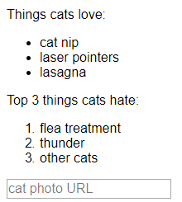

## **Create a Form Element**

You can build web forms that actually submit data to a server using nothing more than pure HTML. You can do this by specifying an action on your formelement.

For example:

<form action="/url-where-you-want-to-submit-form-data"></form>

## **Nest an Anchor Element within a Paragraph**

<h2>CatPhotoApp</h2>

<main>

<img src="https://bit.ly/fcc-relaxing-cat" alt="A cute orange cat lying on its back.">

<p>Kitty ipsum dolor sit amet, shed everywhere shed everywhere stretching attack your ankles chase the red dot, hairball run catnip eat the grass sniff.</p>

<p>Purr jump eat the grass rip the couch scratched sunbathe, shed everywhere rip the couch sleep in the sink fluffy fur catnip scratched.</p>

</main>

<p>

View more

<a href="http://freecatphotoapp.com" target="_blank">cat photos</a>

## </p>

## **Use HTML5 to Require a Field**

<h2>CatPhotoApp</h2>

<main>

<p>Click here to view more <a href="#">cat photos</a>.</p>

<a href="#"><img src="https://bit.ly/fcc-relaxing-cat" alt="A cute orange cat lying on its back."></a>

<p>Things cats love:</p>

<ul>

<li>cat nip</li>

<li>laser pointers</li>

<li>lasagna</li>

</ul>

<p>Top 3 things cats hate:</p>

<ol>

<li>flea treatment</li>

<li>thunder</li>

<li>other cats</li>

</ol>

<form action="/submit-cat-photo">

<input type="text" placeholder="cat photo URL" required>

<!-- Required attribute can be placed anywhere in the Opening Tag -->

<button type="submit">Submit</button>

</form>

</main>

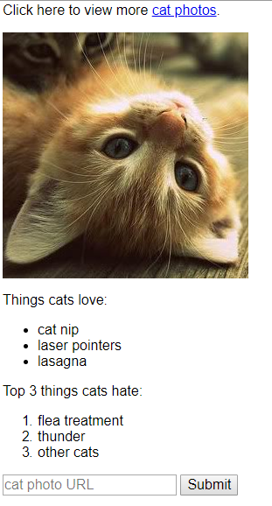

# **Things to remember**

**Cyberpunk 2077 Game**

<https://www.youtube.com/watch?v=OXi6A8osp9s>

<https://www.cyberpunk.net/en/>

**APL Audio Programming Language for Blind People**

* <https://www.researchgate.net/publication/40884101_APL_Audio_Programming_Language_for_Blind_Learners>
* HoloLens <https://www.youtube.com/watch?v=uIHPPtPBgHk>
* HoloLens Microsoft <https://www.google.com/search?q=holo+lens&safe=strict&source=lnms&tbm=isch&sa=X&ved=0ahUKEwjdvrXZlJbhAhXEsKQKHbqZBL0Q_AUIDigB&biw=1093&bih=500#imgrc=50tsf7SQE2YtwM>:
* Blueprints Visual Scripting <https://docs.unrealengine.com/en-us/Engine/Blueprints>
* LUNA <https://www.luna-lang.org/>
* LUNA Overview and Team <https://www.luna-lang.org/#Overview>
* LUNA Docs http://docs.luna-lang.org/

Tutorial Websites:

* UDEMY , example = SQL <https://www.udemy.com/the-ultimate-mysql-bootcamp-go-from-sql-beginner-to-expert/>
* W3school <https://www.w3schools.com/html/default.asp>

**Microsoft Office**

**Management**

**Microsoft Excel**

**Customer Service**

**Leadership**

**Public Speaking**

**Research**

**Healthcare**

**Project Management**

**Microsoft Word**

# **APL: Audio Programming Language for Blind Learners**

